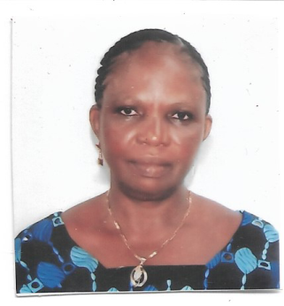**ODEZULU, ANTHONIA ODINAKACHUKWU**

**e-mail: anthoniaodezulu@unn.edu.ng.**

**MY PROFILE:**

**Name:** Odezulu, Anthonia Odinakachukwu

**Sex:**  Female

**File Number:** Js. 8712

**Marital Status:** Married

**Date of Birth:** 28-12-1952

**Place of Birth:** Amansiodo-Oghe

**L.G.A:** Ezeagu Local Government Area

**Nationality:** Nigerian

**Religion:** Christianity

**Residential Address:** Beside See New Hotel Barrack, Nsukka

**EDUCATIONAL QUALIFICATION WITH DATES:**

First School leaving certificate - 1963

NECO GCE - 2005

Diploma in Library Science - 2010 in UNN

Degree (BLS) in Library and Information / Political Sciences 2018 in UNN

Certificate of completion (UNNSIC TCBP) 4th April 2007.

Certificate of National Association of Library and Information science (NALISS) 2016.

Certificate of Chieftancy Award (Aka Ezi Nwanyị dị ụkọ 1 of Iwollo) by The Royal Highness Igwe Raphael Okolo Omasi II of Iwollo Omasi Kingdom. 2018

**Date of Employment** – 2nd October, 1982

**Designation** – Chief Messenger Cleaner

Last promotion as Chief Mess/ Cleaner October 1st, 2000.