**PERSONAL PROFILE**

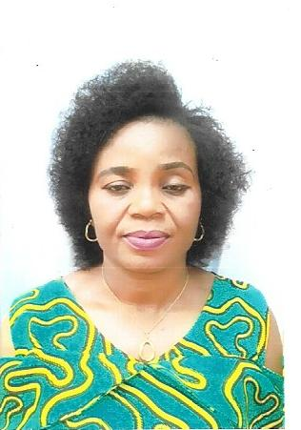

**Family name:** Chidi-Nweloke

**Other names:** Oby Tina

**Maiden name:** Ogbaji

**Contact address:** No. 6 Nnewi Street, Army Barracks, Nsukka.

**E-mail Address:** [oby.nweloke@unn.edu.ng](mailto:oby.nweloke@unn.edu.ng)

**Date of birth:** 26th August, 1966

**Phone no.:** 08066124297

**Nationality:** Nigeria

**State of origin:** Enugu State

**Permanent home address:**  Ugwuode Settlement, Umuofiagu Village, Ukehe

**Next of kin:** Mr. Nweloke Chidi Martins A.

**Contact address of next of kin:** No. 6 Nnewi Street, Army Barracks, Nsukka.

**Phone no. of next of kin:** 07031603640

**Marital status:** Married

**Name of spouse:** Mr. Nweloke Chidi Martins A.

**Number of children:** Four

**Educational Qualifications:**

1. Udoka Primary School, Awka (FSLC) (1977)
2. Girls’ Secondary School, Ukehe (WASSCE) (1984/86)
3. College of Education, Eha-Amufu (NCE) (1990)
4. University of Nigeria, Nsukka (BA) (1998)
5. University of Nigeria, Nsukka (MA) (2013)

**Date of 1st appointment:** 27th February, 2018

**Name of employer:**  University of Nigeria, Nsukka

**Working experience**

1. Community Secondary Alor-Uno (1996 – 2006)
2. St. Cyprian’s Girls’ Secondary School, Nsukka (2007 – 2017)
3. Centre for Igbo Studies, University of Nigeria, Nsukka (2018 till date)

**Offices held:**

* Higher Technical Officer II (2018 till date)

**Job description**

1. Queuing Igbo Artefacts and Cultural materials for display during teaching in acculturation.
2. Documenting outdoor activities covered by the centre
3. Documenting classroom interaction and skill learning during acculturation in the centre.
4. Collaborating with the curator in cataloguing and preservation of the Igbo cultural materials.
5. Carrying out other activities in the centre as directed by the Director.

**Extra-curricular activities:**

1. Fashion and designing
2. Dancing
3. Sporting
4. Singing
5. Bead making
6. Gele/Scarf making

**Referees**

**Name:** Prof. Chris Uchenna Agbedo

**Phone no.:**  08036868498

**Dept.:** Linguistics, Igbo & Other Nigerian Languages, University of Nigeria, Nsukka.

**Name:** Prof. B. M. Mbah, (Esq.)

**Phone no.:** 08038535106

**Dept.:** Linguistics, Igbo & Other Nigerian Languages, University of Nigeria, Nsukka.