**STAFF PROFILE**

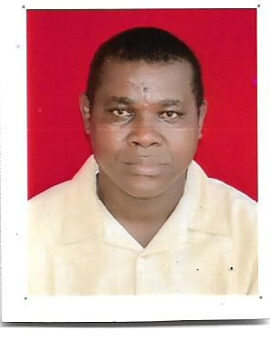

**Family name:**Ogbonna

**Other names:**Samuel Chinwendu

**Contact address:**Centre for Igbo Studies, University of Nigeria, Nsukka Nigeria, Nsukka.

**E-mail address:**samuel.ogbonna@unn.edu.ng

**Date of birth:**25th December, 1975

**Phone no.:**07038417607

**Nationality:** Nigeria

**State of origin:**Imo State

**Permanent home address:**Umuhu – Okwuato, Aboh Mbaise, Imo States.

**Next of kin:**Mrs Florence Ogbonna

**Contact address of next of kin:**No. 5 Poultry Road, Ulo nagu Edem Nru.

**Phone no. of next of kin:**08035700105

**Marital status:**Married

**Name of spouse:**Mrs Florence Ogbonna

**Number of children:**Four

**Educational Qualifications:**

BA (Mass Communication), University of Nigeria, Nsukka (2001)

WAEC/GCE, Nsukka High School, Nsukka, Enugu State (1992/1993)

**Date of 1st appointment:**31st March, 2009

**Name of employer:** University of Nigeria, Nsukka

**Working experience**

* Institute of African Studies, University of Nigeria, Nsukka(2009 – 2015)
* Centre for Igbo Studies, University of Nigeria, Nsukka (2015 till date)

**Offices held:**

* Cinematographer (2009 - 2015)
* Asst. Chief Cinematographer (2021 till date)

**Job description**

1. Film documentaries
2. Film editing
3. Video coverage
4. Video transcription

**Extra-curricular activities:**

Foot balling, Singing, Reading, Filming