**Documenting Local Drug Terminologies in Igbo Southeast Nigeria**

**Crescentia Nwaeze Ugwuona1, Roseline I. Okorji2, Medolu Agatha3, Loveth Ifeoma**

**Fabulous4 Victor Ogonna Ugwuona5, Samuel Chinemere Ugwuona6**

**Abstract**

This study sets out to investigate and document endangered local drug terminologies in Igbo southeast Nigeria. Nigeria, a multilingual country in Africa has copious local drug terminologies going into extinct, for which hardly any proper investigation and documentation exist on such disappearing linguistic terms especially in Igbo, southeast Nigeria. It is disheartening that the Igbo language spoken in South-Eastern Nigeria is endangered with increasingly reduced number of local drug terms. Currently, the dearth of knowledge and documentation of endangered local drug terminologies in Nigeria are at the peak of the lots of language endangerment, as well as health and socioeconomic challenges but have hitherto been neglected by earlier researchers. The need for the documentation of local drug terminologies manifest itself these times of serious language endangerment, as well as health and socioeconomic crisis informed mostly by COVID-19. Investigating and documenting such vital terminologies is imperative in Nigeria’s competitive advantage in the global space for cultural, health (as well as COVID-19 interventions), preservation, and dissemination of Nigeria local languages. In this, we intend to: (i) list the local drug terminologies and the transcription, (ii) point the ones reported to have potentials of curing COVID-19 infections, (iii) the etymology, botanical, and the English names, and (iv) show the sentence examples. The data was collected using in-depth oral interview, group discussion, participant observation, surreptitious recording, and analysed descriptively. The study is useful to the teaching and learning of language documentation.

**Keywords**: COVID-19, endangered language, language documentation, local drug, Nigeria, terminologies.

**Introduction**

There is a growing awareness and concern that Nigeria’s indigenous drug terminologies are vanishing and going into extinct. In Nigeria, virtually local drug terminologies constitute one domain that has the potential to disappear. Evidence has shown that many of these local drugs have been known to cure many deadly diseases such as malaria, typhoid fever, HIV, toothache, vomiting, stomach ache, prostate cancer, pneumonia, measles, COVID-19 and a lot more (see Obeta et al. (2021) for details) Currently, there is evidence of many people who have been cured of COVID-19 infection through local drug medication in southeast Nigeria. Unfortunately, these local drug terminologies are going into extinct due to lack of proper documentation by earlier researchers. Most rural dwellers in Nigeria have testified the effectiveness of these local drugs. Hence, a failure to document them before they disappear would mean irrevocably walling up a window unto the past. The goal of this study is therefore to investigate, list a comprehensive list of endangered and under-described local drug vocabularies with special focus on COVID-19 potential local drug terminologies in Nsukka speech communities of southeast Nigeria. COVID-19 outbreak was first recorded in Wuhan, China and was officially declared a pandemic by World Health Organization (WHO hereafter) on 11th March, 2020. With the COVID-19 pandemic increasing in severity by the day, local communities in Nigeria especially Igbo communities have invoked viral terminologies to effect health challenges, and in the process, embark on lexical innovations to fix gaps needed for linguistics and health challenges. In this, documenting COVID-19 local drug terminologies becomes critical to Nigeria’s competitive advantage in COVID- 19 intervention. Further, the lexical innovations we have seen in Southeast Nigeria since the spread of COVID points to the fact that linguistic creativity is a key part of language, reshaping our ways of engaging with the world.

Documenting endangered languages leads us more directly to the world of our distant ancestors, engages us with the inseparability of language and culture that held out against the loss of diversity. Beyond that, investigating and documenting such vital terminologies is imperative in Nigeria’s competitive advantage in the global space for cultural, health (as well as COVID-19 interventions), and for the preservation and dissemination of Nigerian local languages. Essentially, local drugs have been known to cure not only deadly diseases such as malaria, typhoid fever, HIV, toothache, vomiting, runny stomach, prostate cancer, pneumonia, measles and a lot more, but also coronavirus infections. All local drug terminologies need to be documented because by so doing, our language, health, and socioeconomic situations of the people are being revived and developed. Currently, the dearth of knowledge and documentation of endangered local drug terminologies in Nigeria are at the peak of the lots of the health and socioeconomic challenges, but have hitherto been neglected by linguists. In consequence, Nigeria is increasingly facing unsettling times informed by the coronavirus pandemic which has gripped the world since December 2019. Many Nigerians believe that COVID-19 is mainly targeting those who do not have knowledge and understanding of local drug medication (Ugwuona 2023). In many speech communities where local drug terminologies are disappearing, the inhabitants run the risk of contracting COVID especially in urban areas where the country’s elite, politicians, and the rich, dwell. The challenges of losing one’s life due to lack of knowledge of some certain local drugs terms are daunting, to say the least. Unfortunately, these local drug terminologies including that of COVID-19 are going into extinct, due to lack of proper documentation by earlier researchers. Our distant ancestors who lived before local drug terminologies began to disappear enjoyed healthy living. Although our experience is largely with Indigenous language communities of the southeast Nigeria, we believe this work has global implications and applications. The goal of this study is therefore to investigate and produce a comprehensive list, and documentation of the endangered and under-described (COVID-19) local drug vocabularies from local speech communities of Nsukka, southeast Nigeria comprising mainly of indigenous Igbo speakers.

The Igbo language, spoken in South-Eastern Nigeria is endangered with increasingly reduced number of local drug terms. Five indigenous States that speak Igbo language include Abia, Anambra, Ebonyi, Enugu, and Imo. Speakers of Igbo language can also be found in parts of Delta, Rivers, and Benue states. Speakers found in these areas are not core Igbo speakers. Ugwuona, et al (2020) observe that most times, their speech form influences the host communities (State). It is pertinent to mention that currently, the Igbos are equally found in their large number in different parts of the world. In line with this, Obinna (2003:124) opines that:

The Igbo race as dynamic and expansive as they are should have made a greater and better advantage of their ‘Ubiquitous’ disposition. Where is it you go without seeing the Igbo, not. Just being present but well settled and established and institutionalized? As a highly ingenious people, the Igbos love exploration, and that is part of the reason they are found all over the world, so much so that it has been said, if men live in the moon, the Igbos are there. Igbo language belong to the West Benue Congo group of language family, kwa precisely. The population census of (2001/2002) according to Anozie (2003) placed the population of the Igbo to about 16million. Ugwuona (2014) reports that the population of Igbo speakers is about 30 million. The Igbos like every other tribe in Nigeria presently is battling with the COVID-19 pandemic. As at 12th March 2021, based on NCDC COVID-19 situational report, the Igbo land had recorded 9,156 death case in Nigeria. That notwithstanding, the Igbos have devised means of containing the COVID-19 disease. Out of the three major languages in Nigeria, Igbo is the most endangered (UNESCO, 2001). In consequence, we intend to investigate and document local drug terminologies in Igbo, translate them into English, transcribe them where necessary.

**2.0 Literature Review** In this section, we review the theoretical and empirical study on documentation and local and COVID-19 local drugs. As a new field of language study, documentary linguistics developed over the past 15 years in response to the need to make a lasting record of world’s endangered languages (Austin, 2007). For Austin, one major reason for documentary linguistics is because most languages spoken on earth today will cease to be passed to children or used by anyone if not documented. In this, producing an archive for endangered languages becomes necessary. Across the world, language documentation encompasses the collection, processing, describing and archiving of linguistic data. Language documentation is concerned with the creation and maintenance of a comprehensive record of a language and language use in all conceivable genres and contexts (Himmelmann, 1998 & 2006, Himmelmann and Austin, 3003; Woodbury, 2003). Such a record may include all varieties of a language, depending on the specific goals of the documentation. Although linguists have been involved in language endangerment and documentation issues for a long time, it is generally accepted that a strong shift occurred in this domain towards the end of the 1980s and early 1990s when the plight of endangered languages became more widely recorganised within the linguistic discipline and public domain (Esegbe et al 2015). Current research indicates that 46% of the world’s 7,000 language communities are in danger of experiencing a complete break in language transmission by the end of this century (Wiecha, 2013). Himmelmann (2006) avers that documentary linguistics is a subfield of linguistics that is concerned with the methods, tools, and theoretical underpinning for compiling a representative and lasting multipurpose record of a natural language or one of its varieties. Saheel (2018), posits that a document is a collection of data regardless of the medium on which it is recorded, that generally has permanence and can be read by humans or machines. In other words, a document is an ‘information carrier’ which can be in a printed or online form. Every drug in any given speech community has their natural terms/register. A drug terminology is that name which any speech community uses in the description of their medical related terms. Some Igbo drug terms were derived from the process of description. Dobric (2013) notes that the language of medicine is a broad research field, so broad that there ought to be a specific field of linguistics called medical linguistics. Sadegh-Zadech (2012) notes that medical language has no exact syntax and semantics, and that medical language seems to have technical terms. Igbo drug terminologies are also technical in nature because of the way they were formed as well as the linguistic development due to time-outbreak of the illness or disease they cure.

In other words, natural languages come up and gradually develop naturally in the communities employing them while formal or technical terms are oftem artificially formed.

**2.2 Empirical Studies**

Wilson and Ogri (2014) examined the role of indigenous language broadcasting in national development. These scholars x-rayed a multilingual, pluralistic and multi-ethnic country with upwards of 500 indigenous languages where language should be a tool for National development through promotion of indigenous culture, national Identity, national pride and unity. McIvor1 et al. (2020) carried out a study on indigenous language learning impacts, challenges and opportunities in COVID-19 times in Canada and USA. They observed that Indigenous Language Revitalization (ILR) work is often undertaken face-to-face and regularly includes the most elderly populations in our communities. Therefore, ILR activities that were not already online were vastly affected. Boyd-Barrett’s (2021) study on hospitalized for COVID-19 without information explains how language became a barrier between doctors and patients. He emphasised the use of indigenous language in passing information about COVID-19. Beyond that, information about other illnesses should also be passed in indigenous languages. Some researchers have carried out research on documentation of endangered languages in Africa such as Esegbe et al (2015), Schaefer and Egbokhare (2015), Falix K. Ameka, Friederike Lupke, Bruce Connell, Gerrit Demmendaal (see Essegbey 2015 for details). However, very little research has focused on documentation of local drug terminologies especially in Igbo southeast Nigeria. For instance, Olaoye (2014) carried a study on Sociolinguistic Documentation of Endangered Ethnography of communication in Yoruba language; Mcgil and Blench (2012) worked on Language Documentation, Development, and Ideology in the northwestern Kainji languages in Nigeria; Mbagwu and Obiamalu’s (2008) researched on Documentation of African Languages, a Panacea for the Negative Effects of Globalisation, and a lot more. Ndukauba et al (2020) translated a text on corona virus spread, symptoms and prevention, and a list of 117 COVID-19 terms from English to Igbo language. Onyeaka and Nwaneki explained some corona virus terms in Igbo (2021). However, these researches are essential ones, but the documentation of local drug terminologies has received little or no focus. Research has shown also that Igbo language is among the language communities that are going into extinct. The United Nations Educational, Cultural and Scientific Organisation (UNESCO) predict that Igbo language is among the minor languages that will go into extinction in the next 50 years. In 2008, Achebe Junior organised a research project group from the University of Nigeria Nsukka, and entrusted the project of documenting all the Igbo language lexical terms to the research group. For one reason or the other, the research group and the documentation processes (interview, recordings, translation, description and a lot more) which had gone half way collapsed as soon as he left for London. Since then, there have not been any serious attempt by linguists to document some aspect of Igbo language especially the local drug terminologies which are seriously endangered. In other words, to the best of our knowledge, to date, there has been no known research focused on exactly documenting local drug terminologies and their impact on education, information dissemination, health (as well COVID-19) intervention, and the ways the local drug terminologies present new understanding of cultural diversity, issues of integration, and discrimination in Nigeria.

According to WHO, as at 17th of February 2021, seven different vaccines across three platforms have being rolled in different countries of the world. Vulnerable populations (especially old people and people with other health challenges) in all countries are the highest priority for the vaccination. Documentation is a very important aspect of language study. In some cases, it is referred to as documentary Linguistics. However, outside endangered languages, there is need for languages, as well as events, ideas, happenings to be documented. It helps in posterity as it will be transferred from generation to generation. This study therefore sets out to investigate local drug terminologies associated with viral especially those of COVID-19 in Igbo with special focus on Nsukka local speech communities of Igbo, southeast Nigeria. The objective of the study includes:

1. investigate local drug terminologies in Nsukka local speech communities of Igbo.
2. explain the etymology, and linguistic analysis of the terms.
3. show the example sentences for the use of the terminologies.
4. Translate the local drug terminologies into English and International Phonetic Alphabet (IPA) where possible.
5. Investigate the localization and terminologies of foreign COVID-19 vaccines.

**Research Methodology**

**Data Presentation and Analysis**

In thissection, we present the data and the analysis of the Igbo local drug terminologies. Table one: COVID-19 and other local drug terminologies in Nsukka, the etymology and linguistic analysis.

|  |  |  |  |  |
| --- | --- | --- | --- | --- |
| S/N | Local drugs | Etymology | English/botanical name | Example sentences |
| i. | Ákị́́́ ílu/igogoro | Akị + ilu  Bitter + kola  /bi-tur/ + /kow-lu/ | Bitter kola (*Garcinia kola*). | It is in form of seed. Bitter-kola can be chewed raw as seed, prepared with water or extracted using alcohol. It has anti-viral properties. |
| ii. | Dógóyárò | Dógó+yárò  tall+yaro | Neem Melia indica/azadirachta indica | The three use to be very tall. the leave and the root cures malaria and other infections. |
| iii. | Prekese (Yoruba) | Prekese | Tetrapleura tetraptera | Prekese has anti-virus properties. It can cure different types of infections. |
| iv. |  |  |  |  |
| v. | ụ̀tázị̀ | ụta+zị - ụ̀tázị̀  kor-du,folia | kor-du,folia | Heart shaped bitter leaf. The ụtazị soup is good for persons suffering from diarrhea and stomach ache. |
| vi. | Yàbásị̀  (Hausa name) | Yàbá+sị̀  spead+many | Onions/garlic  /gaar-lik/garlic-a*llium sativum.* | Aromatic bulb used as seasoning. Garlic is useful in chronic cough, arthritis, and constipation. Garlic has also been mentioned to protect from epidemic diseases, and COVID-19. It activates macrophages and promotes immunoglobulins. |
| vii. | Akanwụ | aka+nwụ  make+sour | Sulphur /sul-fur/ | Sour substance that can be used to preserve food, and cure certain ailments. |
|  | Oroma nkirisi | oro+ma+nkirisi  roundish+small | Citrus aurantifolia  lime /lim/ | A small soar roundish fruit that has soar/bitter taste. Lime is popular as antioxidant activity, immunomodulation, and antibacterial activities.  lime cures stomach ache and infection problems. |
| ix. | ụ̀dọ̀ ákpu ényí | ụ̀dọ̀+ákpu+ényí  robe+negative+strong | Magnoliopsida /mag’nowl-yu/  *Tinospora cordifolia* | The parts of the plants are used in folk/ herbal medicine, example: fruits (jaundice and rheumatism), root (leprosy, diarrhea, and dysentery), stem (jaundice, skin diseases, and fever), bark (cancer), leaves (gout, ulcers, jaundice, fever, and wounds, and to control blood glucose). |
| x. | Jínjà | Ji+nja  Hold+stire  (borrowed from Hausa) | Ginger /jin-jur/  *Zingiber officinale* | Ginger is used as a hot spice; help reduce oxidative stress and inhibit superoxide production. Dried ginger possesses potent anti-inflammatory and analgesic activities, has a better effect against swine flu (H1N1), COVID infections, and human respiratory syncytial virus in human respiratory tract cell lines. There are antiretroviral sesquiterpenes in ginger. |
| xi. | kùkúmà Tumerik | Ku+ku+ma  Fan+know | /tur-mu-rik/. Monocots. *Curcuma longa.* | Viruses such as HIV, Tat protein acetylation, inhibited HIV-1 integrase while curcumin boron complexes inhibited HIV-1 and HIV-2 proteases though reported no antiviral effect in a clinical trial for HIV. Turmeric is blood purifier, antioxidant, immunomodulating, anti-inflammatory, antimicrobial, and has anticancer activities. |
| xii. | ụ́tụ́rụ́kpè | ụ́tụ́rụ́+kpè  magnanimous | Plantae/ụ́tụ́rụ́kpè  /ʊtʊrkpe/ | the ụ́tụ́rụ́kpè leaf is used in curing certain diseases of which one of it is stomach ache. |
| xiii. | Égbú | E+gbu  It+cut | giloy Tinospora.  Plant family égbú | The bark and the leaves help in the treatment of runny stomach and stomach ache. The root, stem, back, and the leaves are useful as an herbal remedy of one disease or the other depending on the preparation. |
| xiv. | àgbàrọ́fụ́ụ́/ akamtoro/ | agbarụ+ọfụụ  specie +new | Eupatorium domatium. Plant family/Plantae discovered newly in Igbo land as a very effective medicine for wounds and cuts. | the leaves are used as in Igbo folk medicine. The liquids from the leaves are used for the treatment of wounds and cuts that are bleeding. |
| Xv | Úzízá | Uzi+za  Plantable | Brassicaceae and Mustard family African Pepper/Ngero pepper/ Guinea pepper (xylopia aethiopica) | Úzízá seed is one amongst the medicinal seeds in the Ibo land. Some use it for spicy, others use it for stomach ache. |

The table above reveals some local drug terminologies, their etymology/source, English, and botanical name. We showed also some sentence examples of each of the local drug terminologies (i, - xv) have Igbo etymology/source, English names/equivalent as well as the botanical terms where possible. The donor language for prekese is Yoruba, while that of yabasi is Hausa.

Below are the pictorial expositions of some of the local drugs

**Figure i. ákị́ ílū/igogoro (bitter kola)**

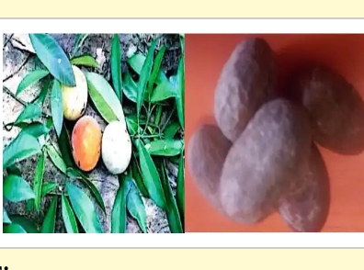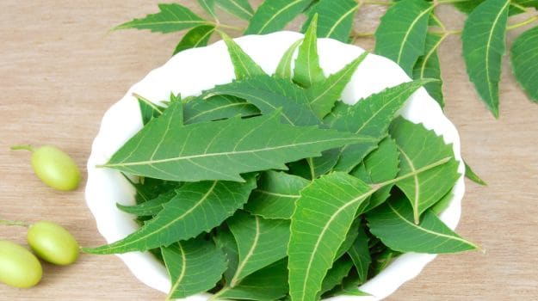

**Figure ii. Dogoyaro (neem)**

**Both the leaf, stem, and root of the neem are used as medicine.**

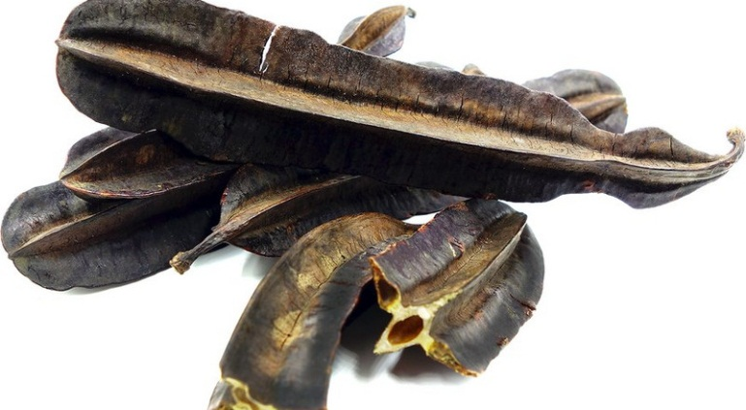

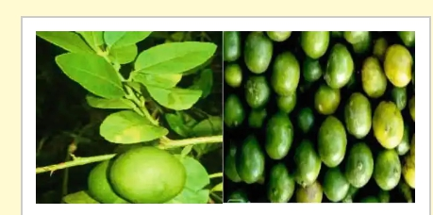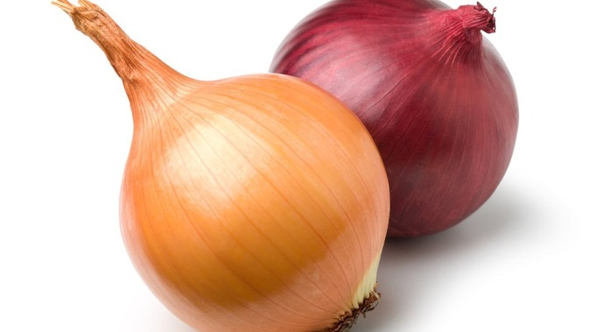

**Figure iii. prekese Figure iv. oroma nkịrịsị (lime) citrus aurantifolia** Figure v. yabasị (onion)

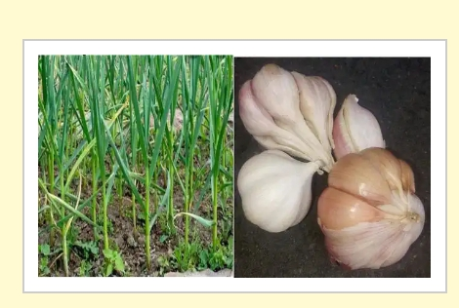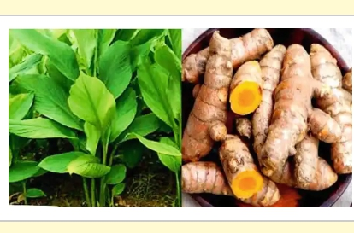

Figure vi. galik onions (*Allium sativum*) Figure ix. ginger

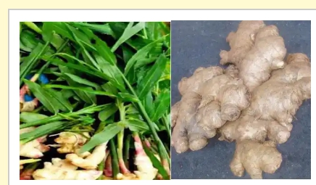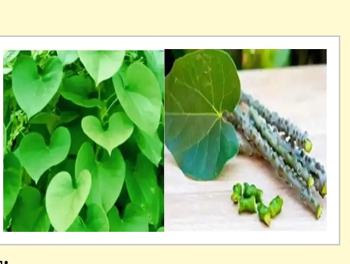

Figure vii. **ụdọakpụ enyi (***Tinospora cordifolia***)**

Source: All from Obeta et al. (2021)

According to our informants, preparations of some local drugs could be made using a single plant or combination depending on the availability and the type of sickness and the recommendations of the native doctors. The local drug terminologies and the pictorial expositions are for us to know the terminologies and their nature. Regardless, self-medication should be avoided. Patients are advised to see the native doctors and appropriate medical practitioners for proper advice.

**Conclusion**

For one to be well informed and be able to digest all the necessary information about local drug terminologies, there is the need for all necessary information on the local drugs to be documented in the language of the immediate environment or mother tongue. Most of the people residing in the rural areas are either semi literates or illiterates in English language. As for information concerning the deadly COVID-19, there is an urgent need to translate all the available literature in English into Nigerian indigenous languages to carry the rural dwellers and local communities along.

**References**

Anozie, C. (2003). Igbo kwenu: Akuko Na Omenala Ndi Igbo.Enugu: Computer Edge Publishers.

Austin, J. L. (1975). *How to do things with words.* Urmson, J. O., Sbisà, Marina. (2nd ed.).

Cambridge, Mass: Harvard university press.

Austin, P. K. (2007). Survival of languages. In F. Shuckburgh (ed), Survival: Darwin Colleges Lectures. Cambridge: Cambridge University Press.

Boyd-Barrett, C. (2021). Hospitalized for COVID-19 without information: What Californians who speak an indigenous language often face. Retrieved from [*https://justiceinaging.org/hospitalized-for-covid-19-and-no-information-what-californians-who-speak-an-indigenous-language-often-face*/](https://justiceinaging.org/hospitalized-for-covid-19-and-no-information-what-californians-who-speak-an-indigenous-language-often-face/).

Braswell, H. (2020). Comparing the COVID-19 vaccine developed by Pfizer, Moderna, and Johnson & Johnson. Retrieved from http://[www.stances](http://www.stances). Accessed on 8th March,2021.

Esegbey J., Henderson B, Laughlin F. MC (2015). *Language documentation and endangerement in Africa*. Amsterdam/Philadelphia: John Benjamin Publishing Company.

Frajzyngier and Erin Shay, characteristics (2012). The Afroasiatic Languages. Cambridge University Press). Online web @<https://www.colorado.edu/linguistics/research/language-documentation>.

Gilles Adda, Martine Adda-Decker, Odette Ambouroue, Laurent Besacier, David Blachon, (2016). Innovative technologies for under-resourced language documentation: The BULB Project. Workshop CCURL. *Collaboration and Computing for Under-Resourced Languages - LREC,* May 2016, Portoroz, Slovenia. ffhal-01350124f.

Himmelmann, N. (2006). Language documentation: what is it and what is it good for? In J. Gillett, N.P. Himmelmann & U. Motel (eds). *Essentials of language documentation (Trends in Linguistics Studies and Monograph*), PP.1-30. Berlin: Mouton de Gruyere.

Himmelmann, N. P. and universitat Bochum, R. (2002). ¨ Documentary and descriptive linguistics. In Osamu Sakiyama and Fubito Endo (eds.), Lectures on Endangered Languages 5, 37-83. Kyoto: Endangered Languages of the Pacific Rim. Hyman, L. (2003). Basaa (A43). In Derek Nurse et al., ed- ´ itors, The Bantu languages, pages 257–282.

Himmelmann, N.P. (1998). Documentary and descriptive linguistics. Linguistics 36; 161-195.

Ndukauba, K., & Ohaike, N. B. (2020). Disseminating information on covid-19 to rural dwellers through translation: a panacea to COVID-19 spread. *IJRDO - Journal of Social Science and Humanities Research* 5(5), 43-57.

# on 10th March, 2021.

Onyeaka, H. K. & Nwaneki, C. (2021*). ụfọdụ ihe banyere corona virus n’asụsụ Igbo: explaining corona virus in Igbo language*. The crater library.

Schaefer and Egbokhare (2015). Archaeological inspiration and historical inference; Directions for Edoid linguistic studies. In Essegbe et al (eds.) *language documentation and endangerment in Africa*. Amsterdam/Philadelphia: John Benjamin Publishing Company.

Woodbury A. C. (2003). In Peter K. Austin (ed.) *Language Documentation and Description*, vol. 1, 25-51. London: SOAS, University of London.

Woodbury, A. (2011). Language Documentation. In Peter K. Austin and Julia Sallabank (eds.) *The Cambridge Handbook of Endangered Languages*, 159-186. Cambridge: Cambridge University Press SDF.

Wurm, S. A. (2001). Atlas of the world’s languages in danger of disappearing (2nd ed.). Paris: UNESCO Publishing/Pacific Linguistics.[Google Scholar](http://scholar.google.com/scholar_lookup?title=%0a%20%20%20%20%20%20%20%20%20%20%20%20%20%20%20%20%20%20Atlas%20of%20the%20world’s%20languages%20in%20danger%20of%20disappearing%0a%20%20%20%20%20%20%20%20%20%20%20%20%20%20%20%20&author=SA.%20Wurm&publication_year=2001).

Ugwuona, C.N. (2023). Language use and the Spread of COVID-19 pandemic in Igbo Culture Area. Scope Journal, 13(3), 912-921. Available @ [www.scope.journal.com](http://www.scope.journal.com).

Ugwuona, C. N. (2015). Boko Haram as a Discourse Topic in Nigerian Print Media from 2010- 2012. vol. 5, 53-57. In *Journal of Culture, Society and Development*, vol. 5, 53-57. Online Journal @ http://www.iiste.org/journals.

**N**